SIMATS ENGINEERING
ASSESSMENT TOOL III – Penetration testing Task
Course: ETHICAL HACKING Code:ITA1412 CO: CO3 AT3
Duration: 90 min Total Marks: 50 Reg No / Name : NIVEDHITHA G(192521231)

1. An organization has commissioned an external penetration test to determine how much information an unauthorized attacker could gather about its internet-facing infrastructure without directly attacking its systems. Using the theHarvester tool against the authorized domain tesla.com, conduct a comprehensive reconnaissance exercise to identify publicly available email addresses, subdomains, hostnames, IP addresses, URLs, and other relevant infrastructure information. Organize and analyze the collected information to determine how it contributes to the external attack surface, including the risks associated with exposed employee information, unnecessary subdomains, hostnames, and externally hosted services. Finally, prepare a security assessment explaining the information discovered, the most valuable reconnaissance findings, how multiple pieces of information could be combined by an attacker, the associated risks, recommended controls to reduce information disclosure, and which findings should be validated during subsequent penetration-testing phases. Required Tool: theHarvester.
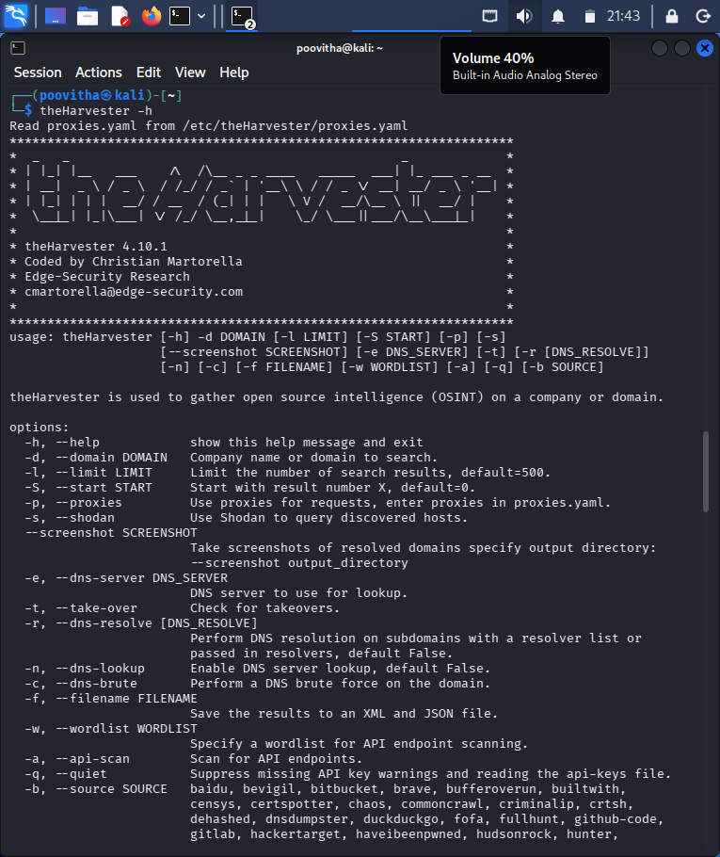
2. During a penetration-testing engagement, assess the publicly accessible web application testphp.vulnweb.com using the Nikto tool to identify potentially exposed files and directories, insecure HTTP methods, server configuration weaknesses, information-disclosure issues, outdated components, dangerous files,and other potential security weaknesses. For every significant finding, collect appropriate evidence and determine whether it represents a confirmed vulnerability, a configuration weakness, or an issue requiring further manual validation. Prepare a final assessment including the commands used, significant findings, supporting evidence, potential security impact, likelihood of exploitation, recommended remediation measures, methods for validating remediation, and a prioritized list of the most important findings, with particular attention to exposed files, server-version information, directory listings, insecure HTTP methods, and outdated components. Required Tool: Nikto.
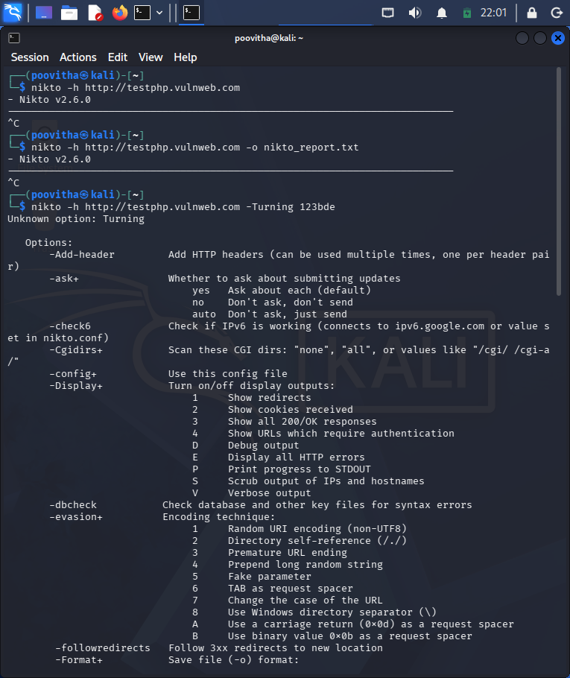

3. A company is conducting an external security assessment to determine whether its DNS infrastructure discloses more information than intended. Using the Dig utility against the authorized target domain zonetransfer.me, perform a detailed DNS enumeration exercise by identifying and documenting the available A,AAAA, MX, NS, CNAME, TXT, SOA, and other relevant DNS records,determining the authoritative servers, and assessing whether an unauthorized DNS zone transfer can be requested. Analyze the results from an attacker’s perspective and explain how DNS records can reveal mail infrastructure, server aming conventions, hostnames, service relationships, and other infrastructure information. Your assessment should identify the DNS records and authoritativeservers, determine whether a zone transfer was possible, explain the additional information exposed by a successful zone transfer and the risks of unrestricted AXFR access, discuss how DNS information can be combined with other reconnaissance techniques, recommend appropriate DNS security controls, and explain how remediation can be verified. Required Tool: Dig.
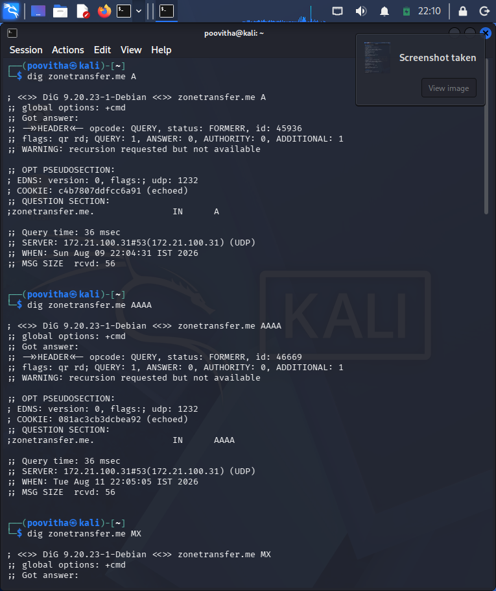
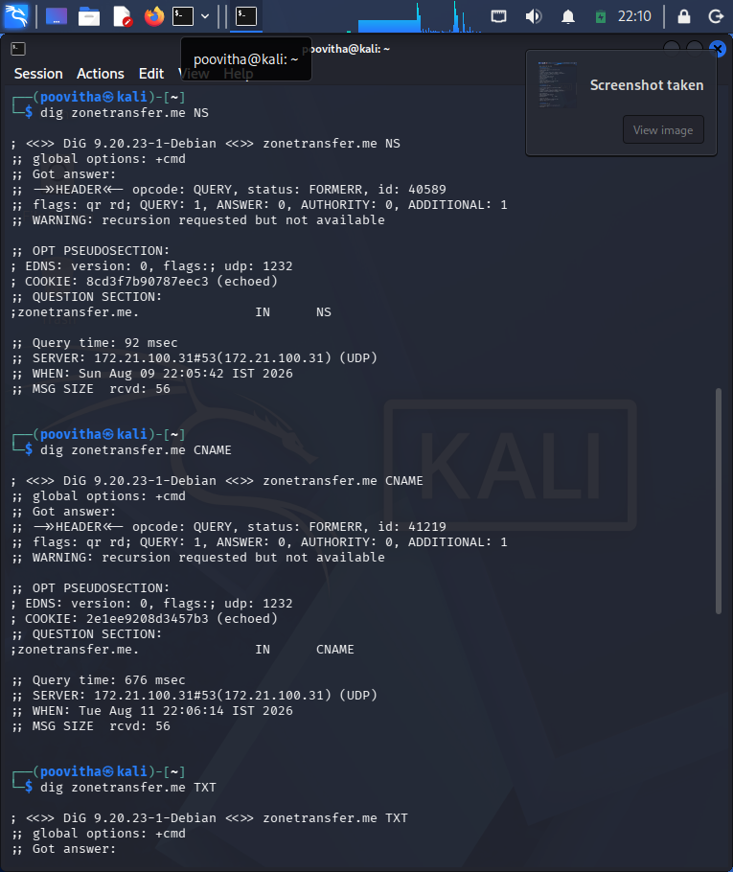
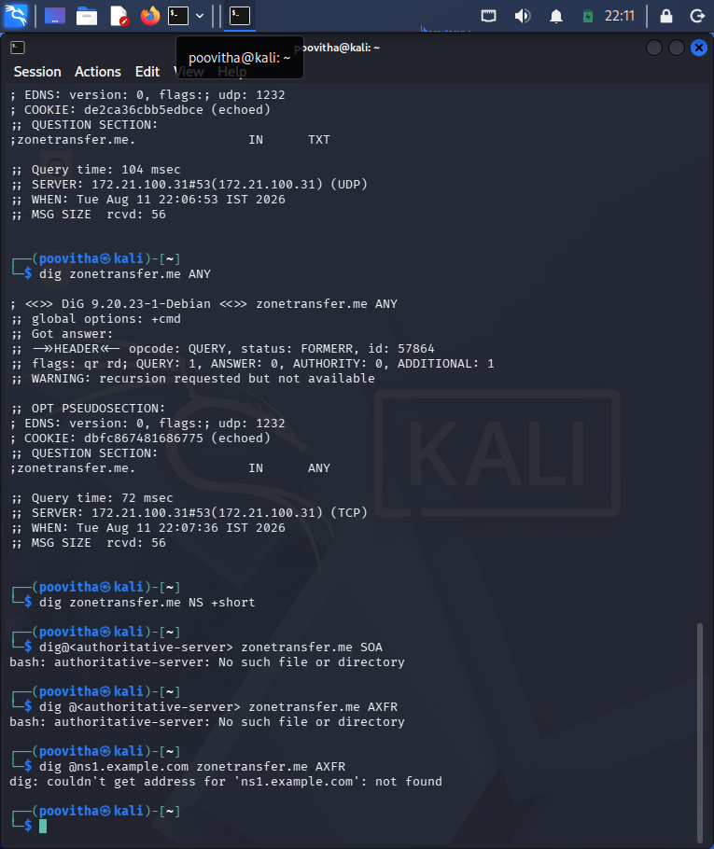

4. As part of an internal penetration-testing engagement, assess the authorized Windows/SMB target 192.168.1.100 using Enum4linux to determine what information could be obtained through SMB and NetBIOS enumeration before attempting exploitation. Perform comprehensive enumeration to identify available users, groups, shared resources, domain or workgroup information, operating-system details, password-policy information, NetBIOS information, and other exposed SMB configuration details permitted by the target. Analyze the collected information from an attacker’s perspective and determine whether it could facilitate credential attacks, privilege escalation, unauthorized access to shared resources, vulnerability identification, or lateral movement. Prepare a report containing the commands used, identified users and groups, discovered shared resources, relevant system and domain information, evidence of anonymous or null-session enumeration, security implications, relationships between accounts,groups and privileges, risks of unnecessarily accessible SMB shares,recommended controls, and a prioritized remediation plan covering SMB configuration, access control, authentication, patching, and network segmentation. Required Tool: Enum4linux.
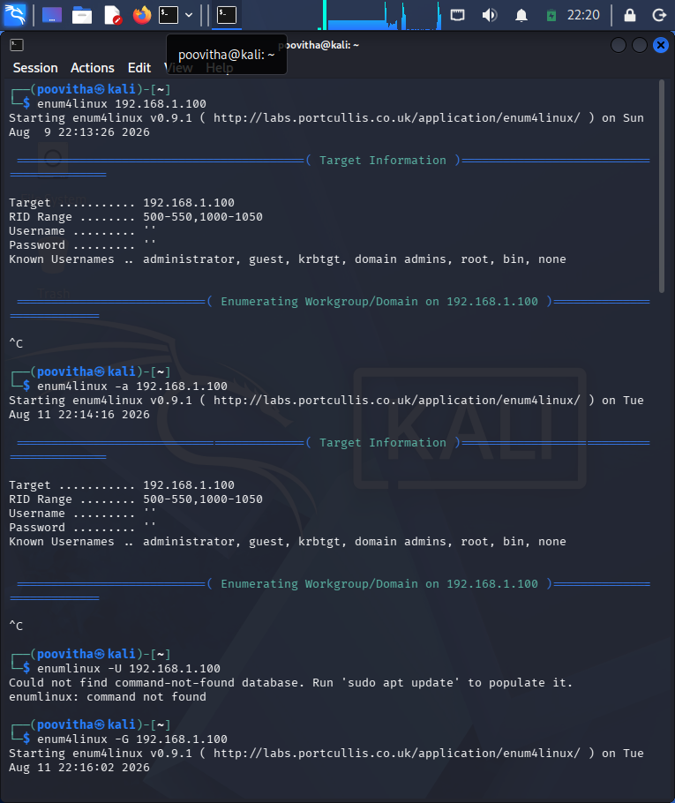
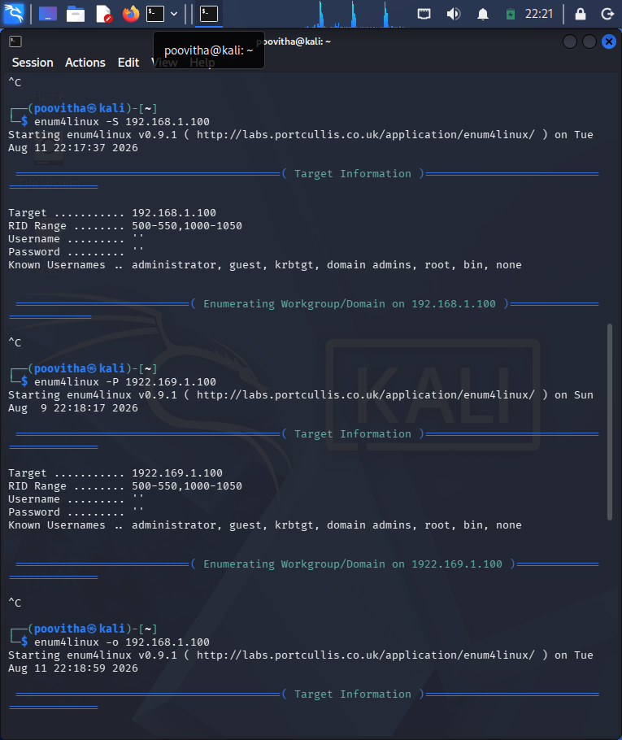
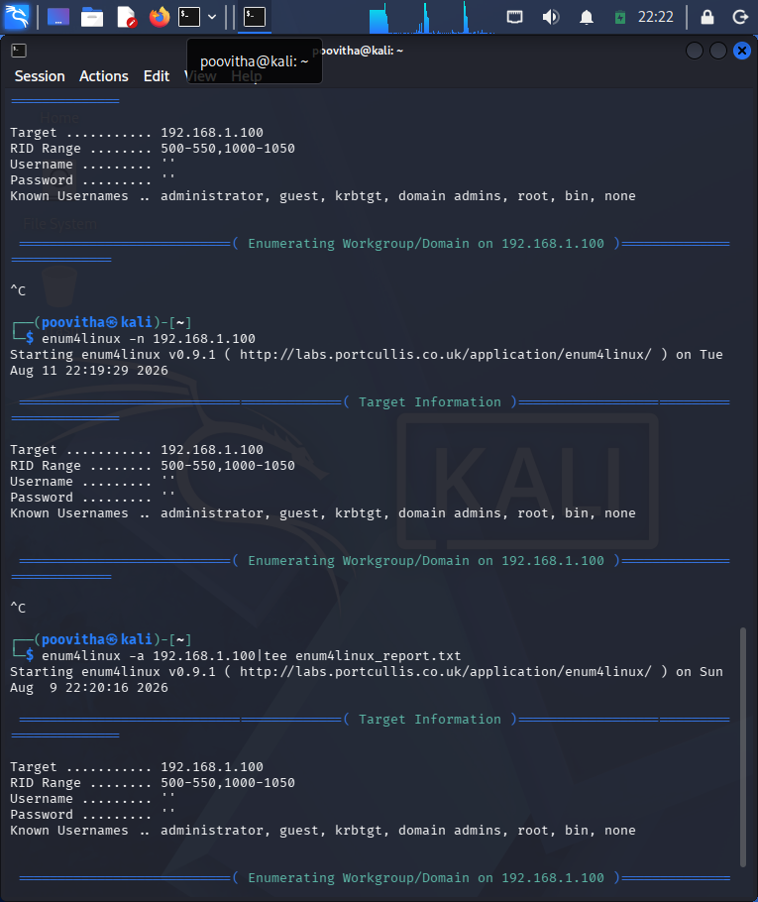

5. During an external penetration-testing engagement, assess the authorized target scanme.nmap.org using Netcat (nc) to connect to accessible TCP services and collect service responses and banner information. Analyze the responses to determine what technical information the target voluntarily discloses, including service type, protocol, software name, version information, HTTP response headers, operating-system clues, and other implementation details. For each significant observation, explain what information was disclosed, which service provided it, how it could assist an attacker with fingerprinting, whether version information could be correlated with known vulnerabilities, whether the finding represents a vulnerability or merely information disclosure, what additional validation is required, and what remediation measures could reduce unnecessary exposure. Finally, explain how the organization should monitor and periodically reassess externally exposed services and discuss the security implications of service-banner exposure and how accurate service fingerprinting can make subsequent attacks more targeted. Required Tool: Netcat (nc).
